# **Name: Abdurrahman Qureshi**

# **Roll No: 242466**

Practical No: 3

Date Of Performance: 28/07/2025

Aim: Study of packet sniffer tool WireShark via different network filters

Promiscuos Mode:

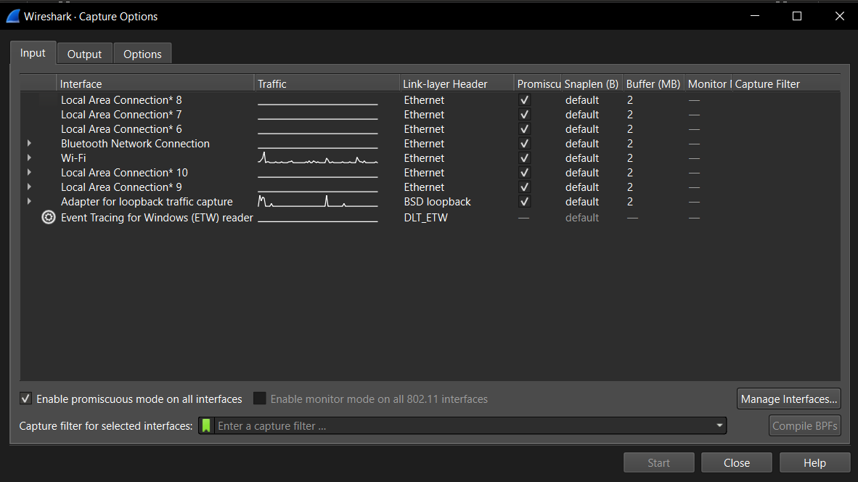

1. ip and ip.addr == ?

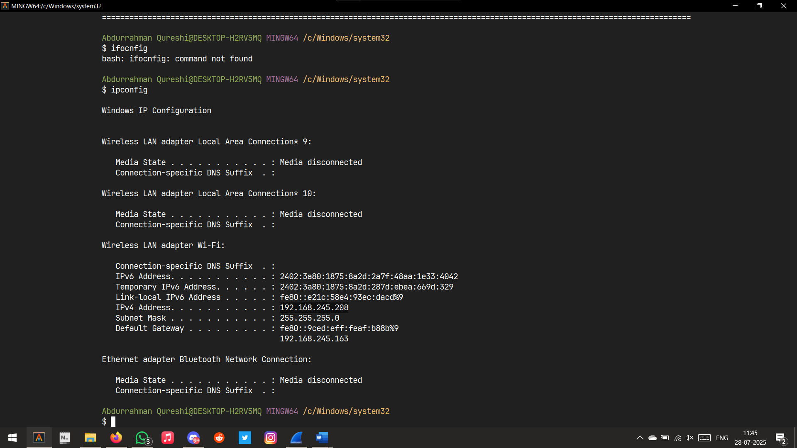

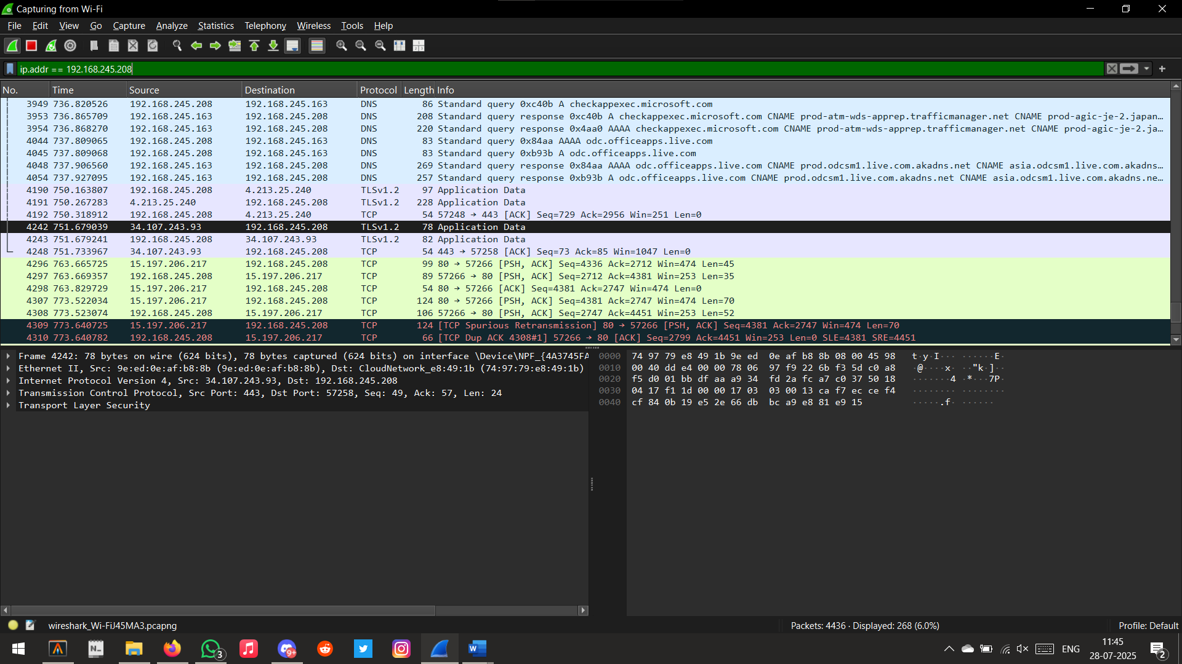

1. tcp.port == 80

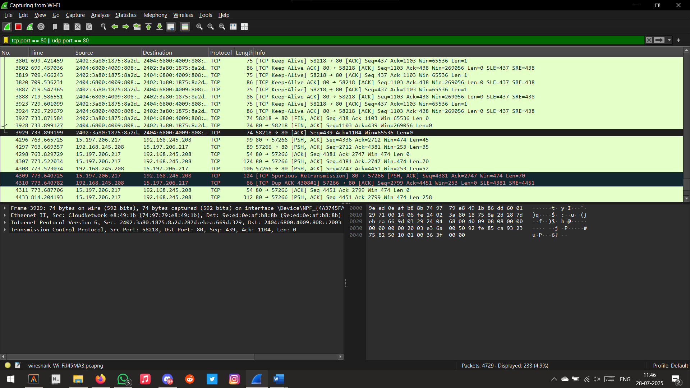

1. udp.port == 80



1. icmp

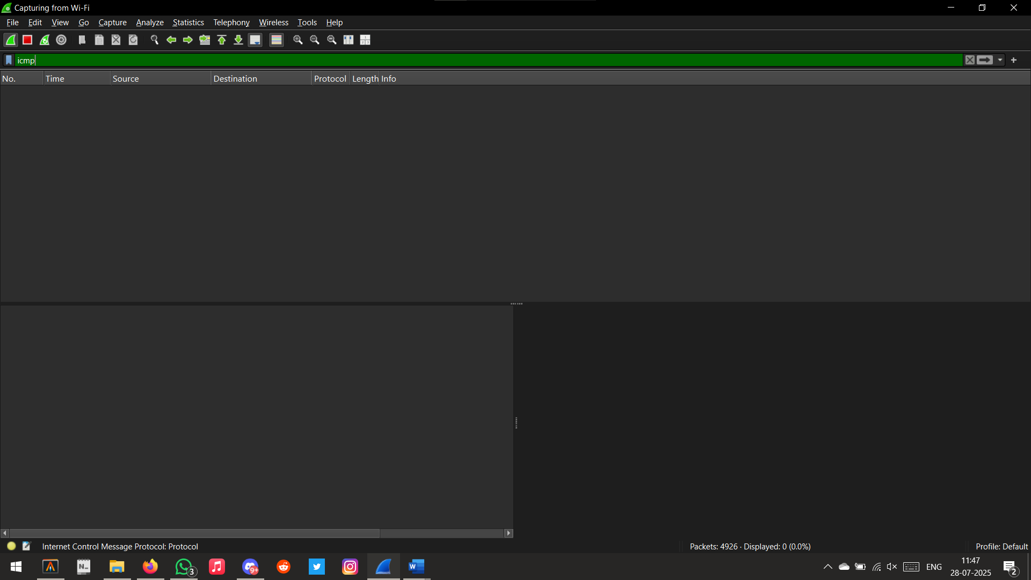

1. https

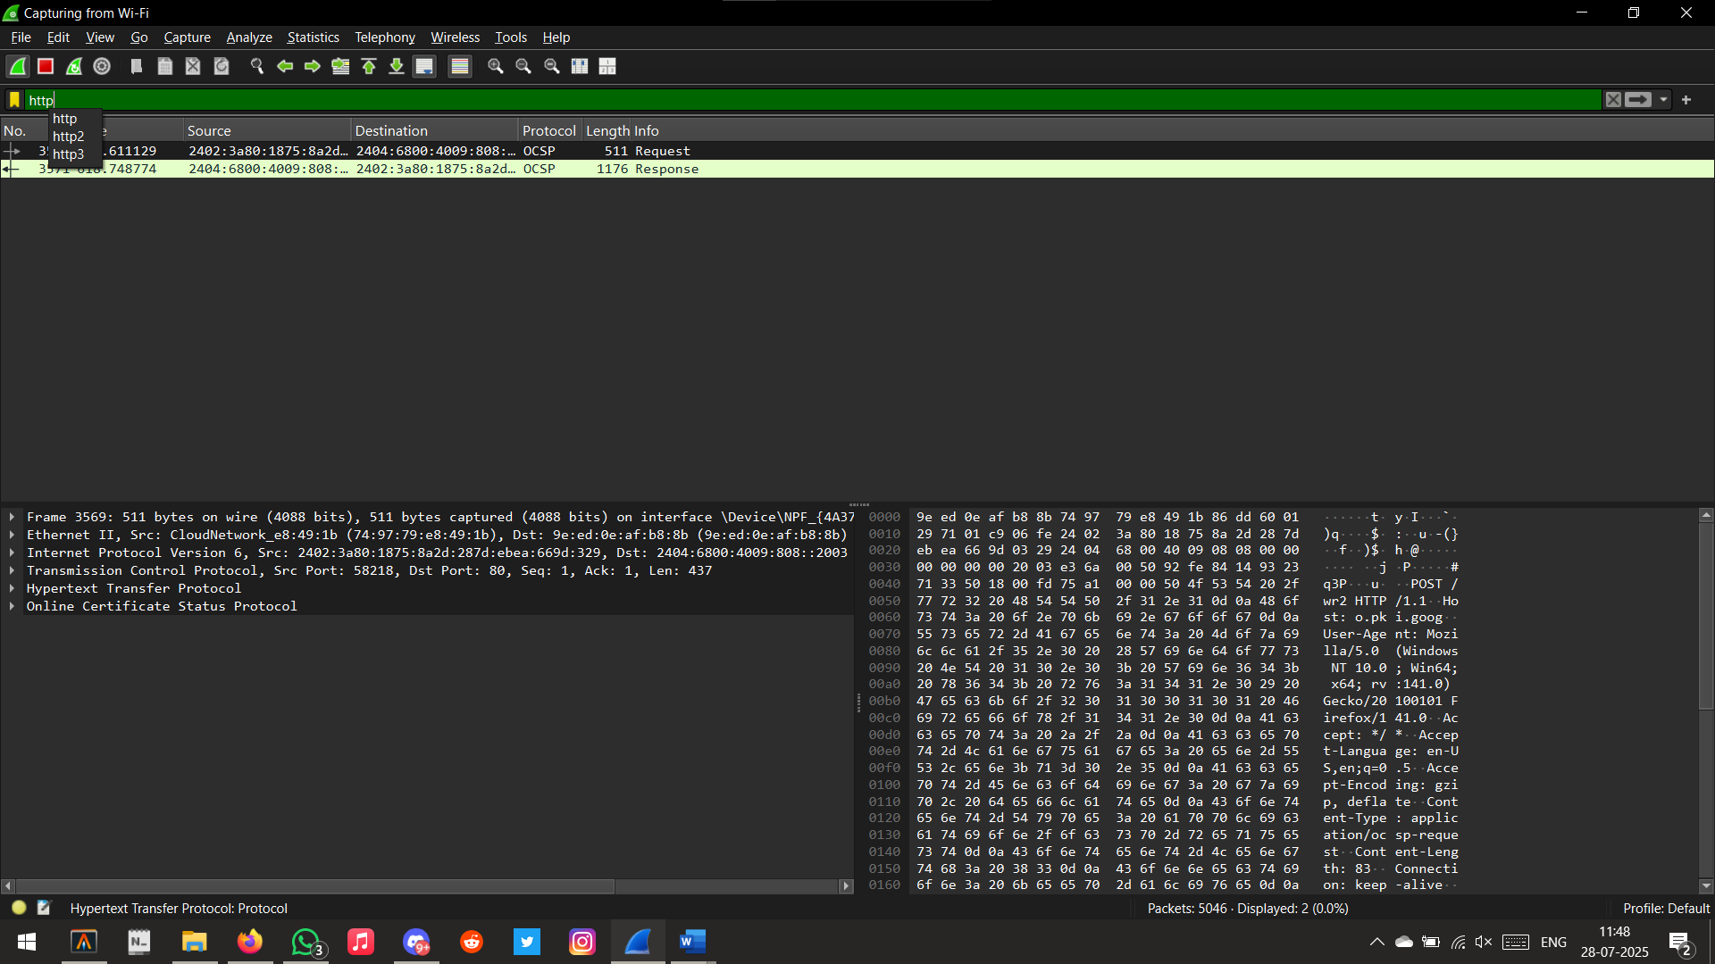

1. dns

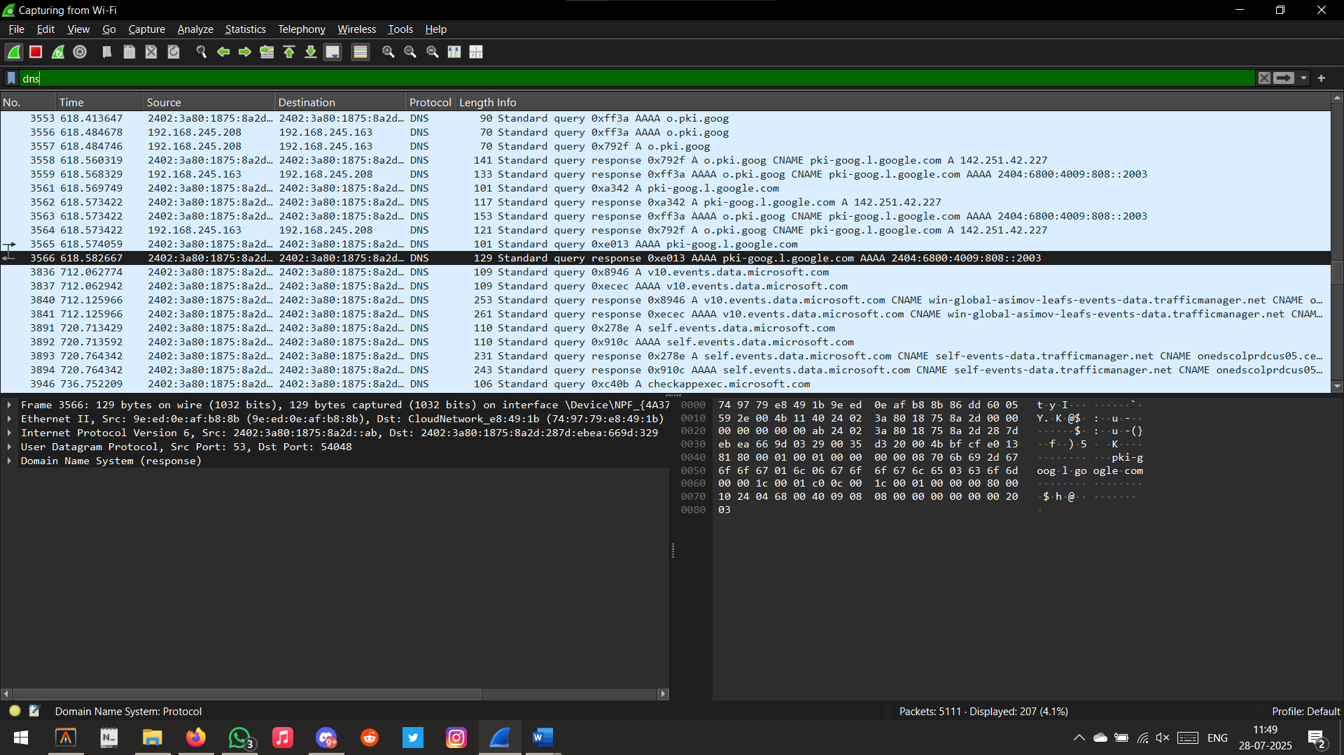

1. tcp.port == 443

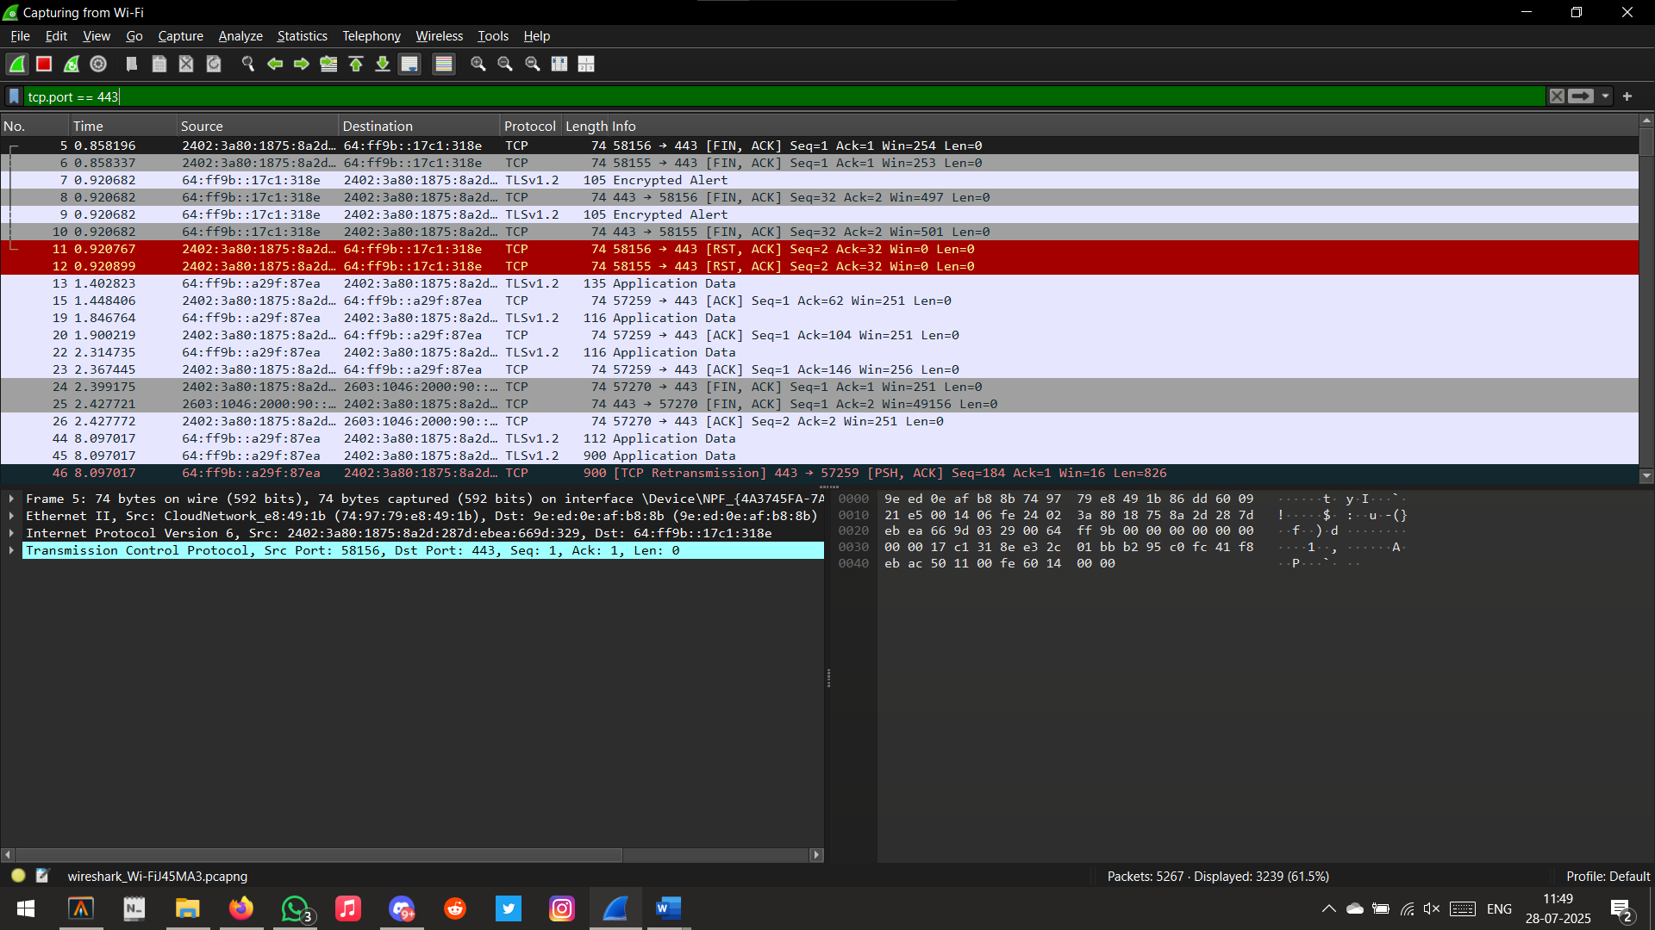

1. arp

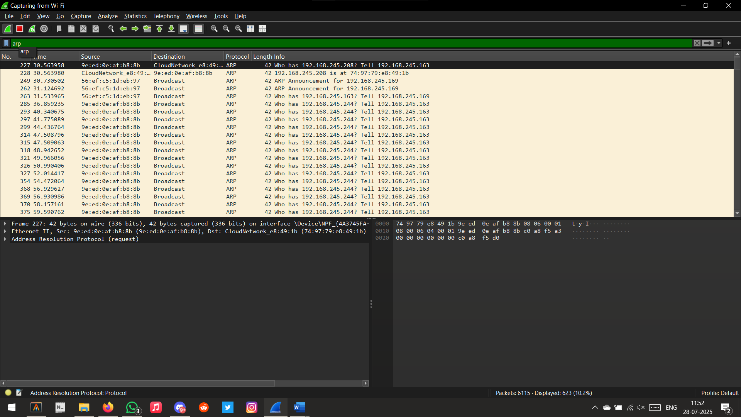

1. dhcp

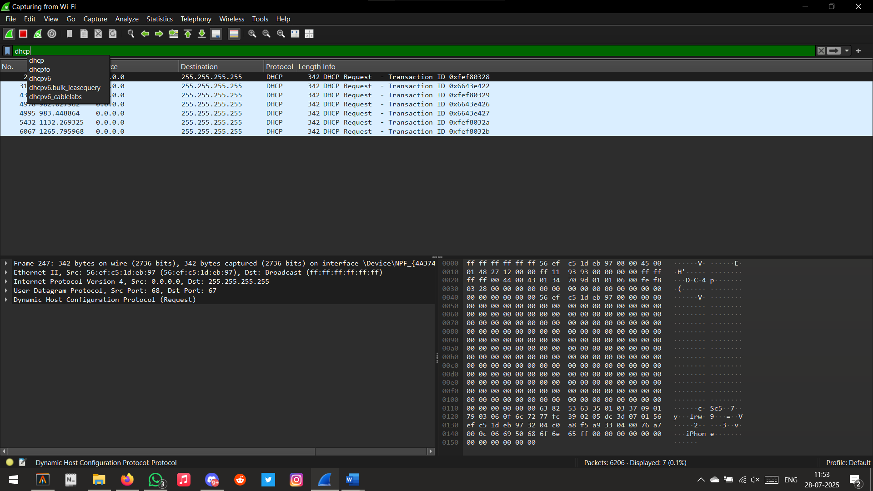

1. ssl

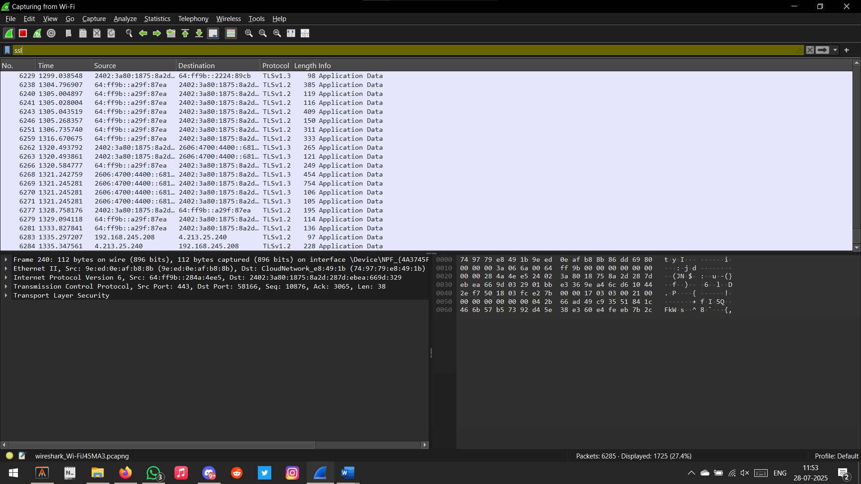

1. http.request

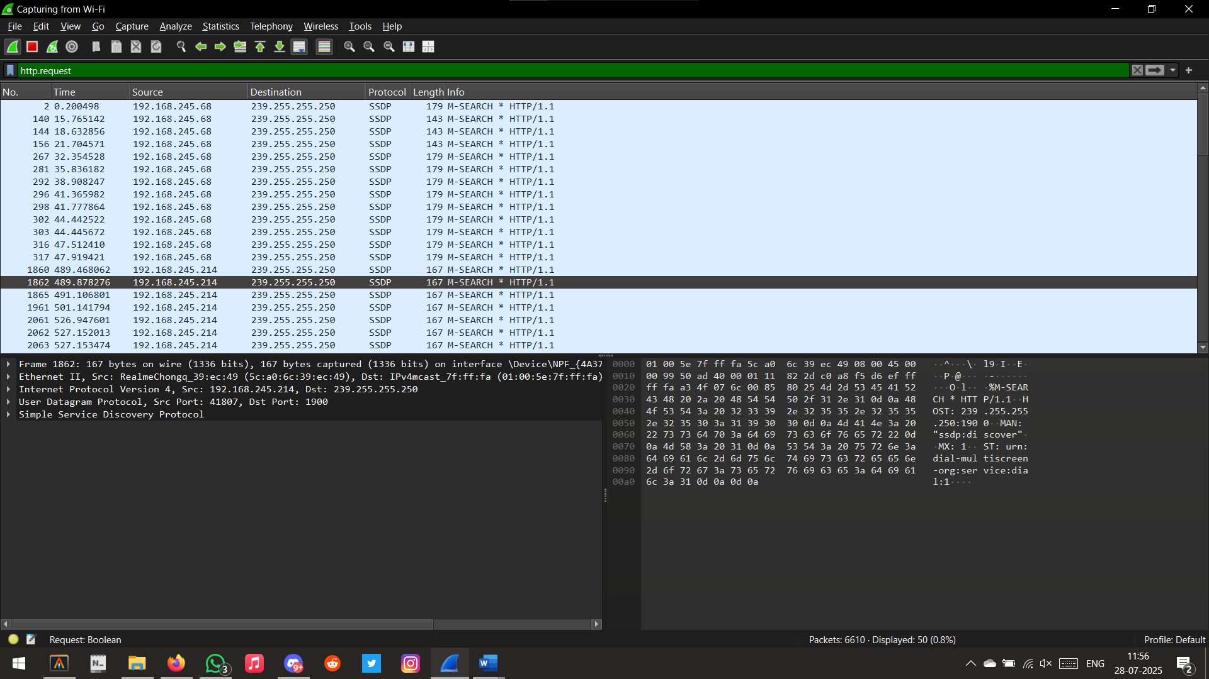

Non-Promiscuos Mode:

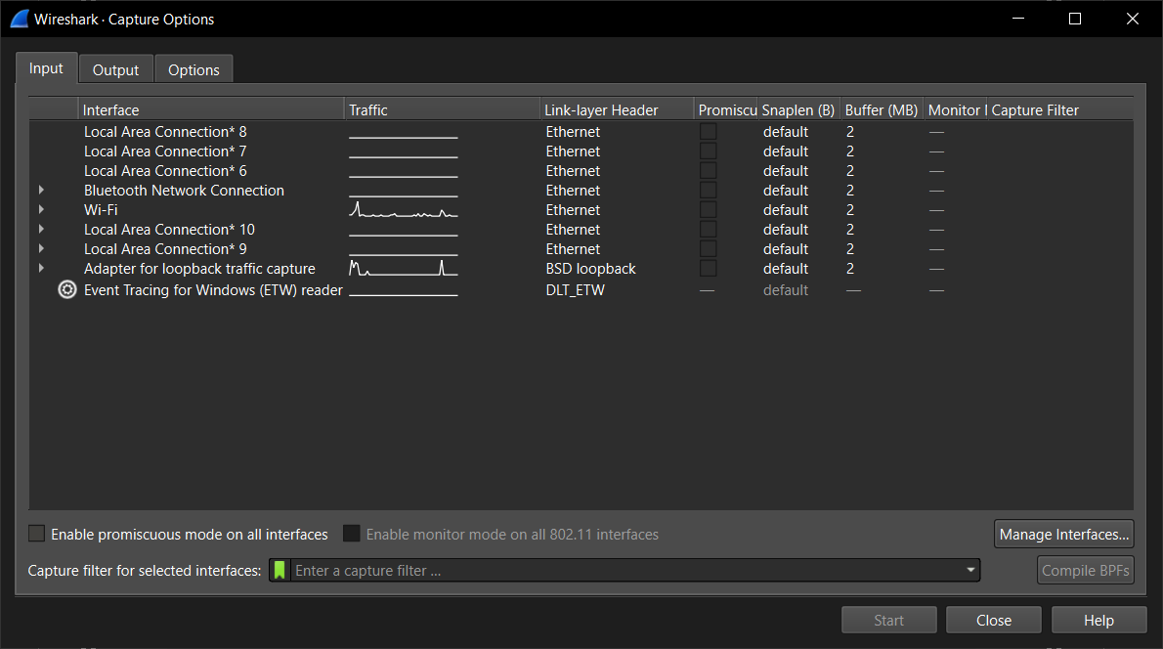

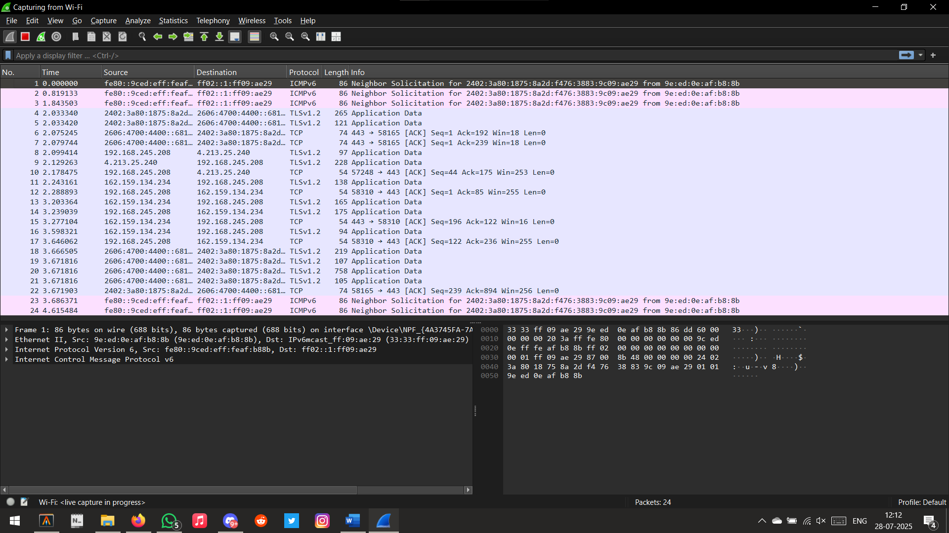

1. Dhcp

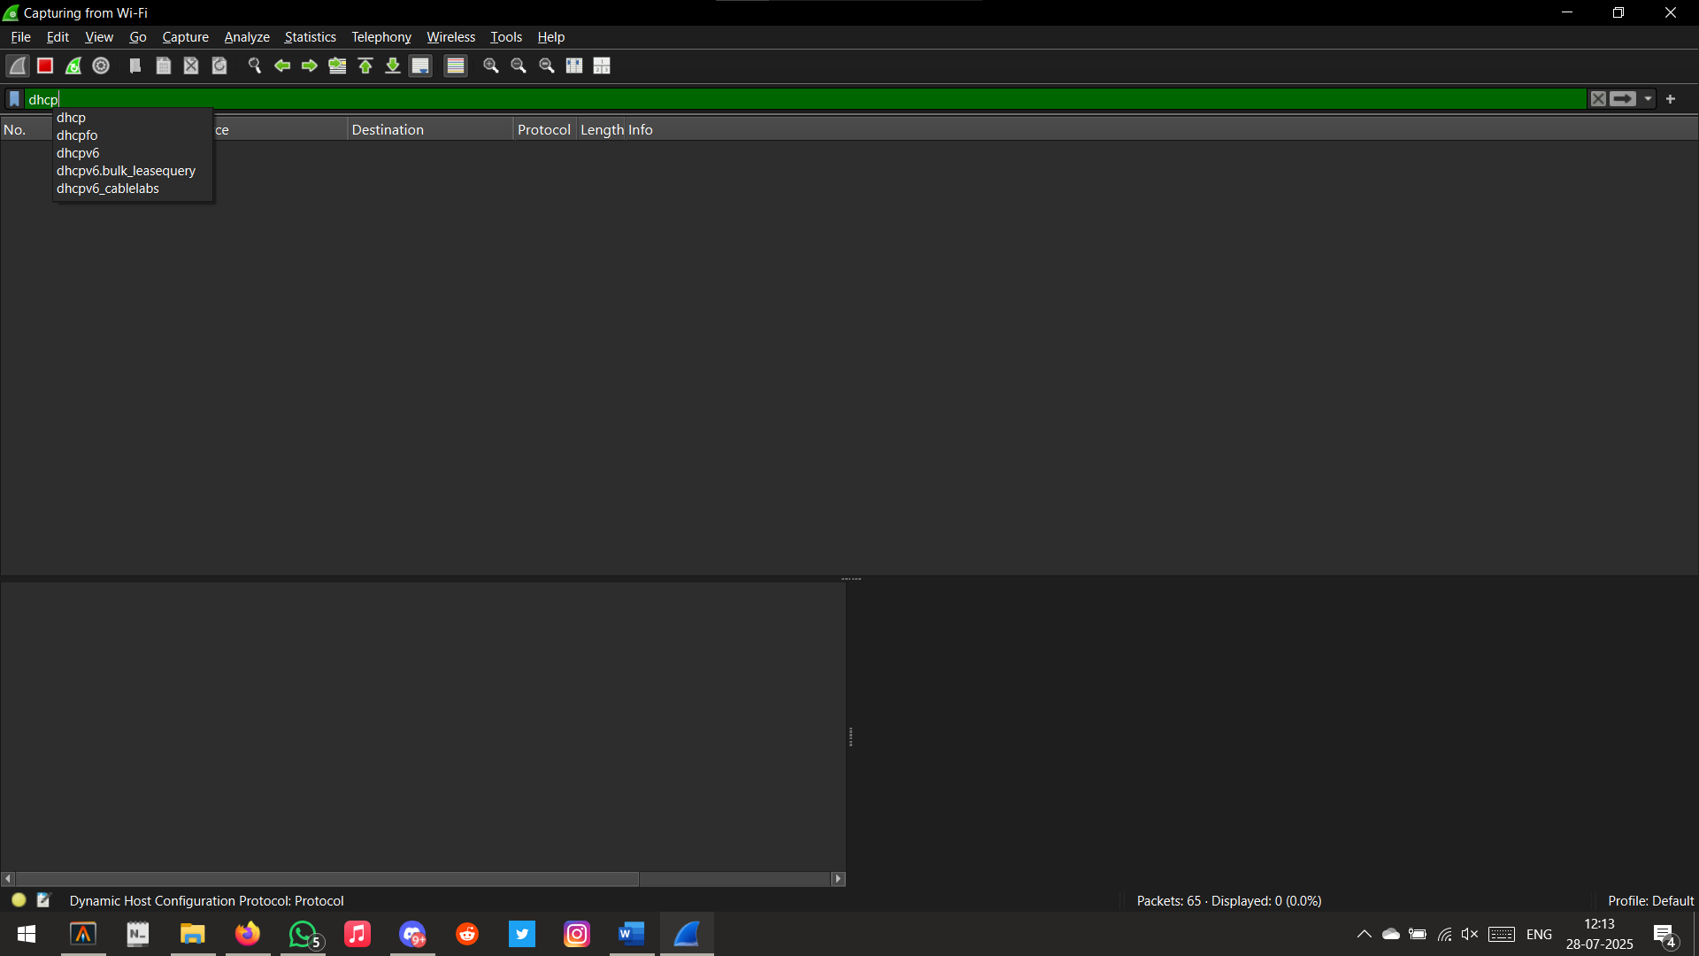

1. Ssl

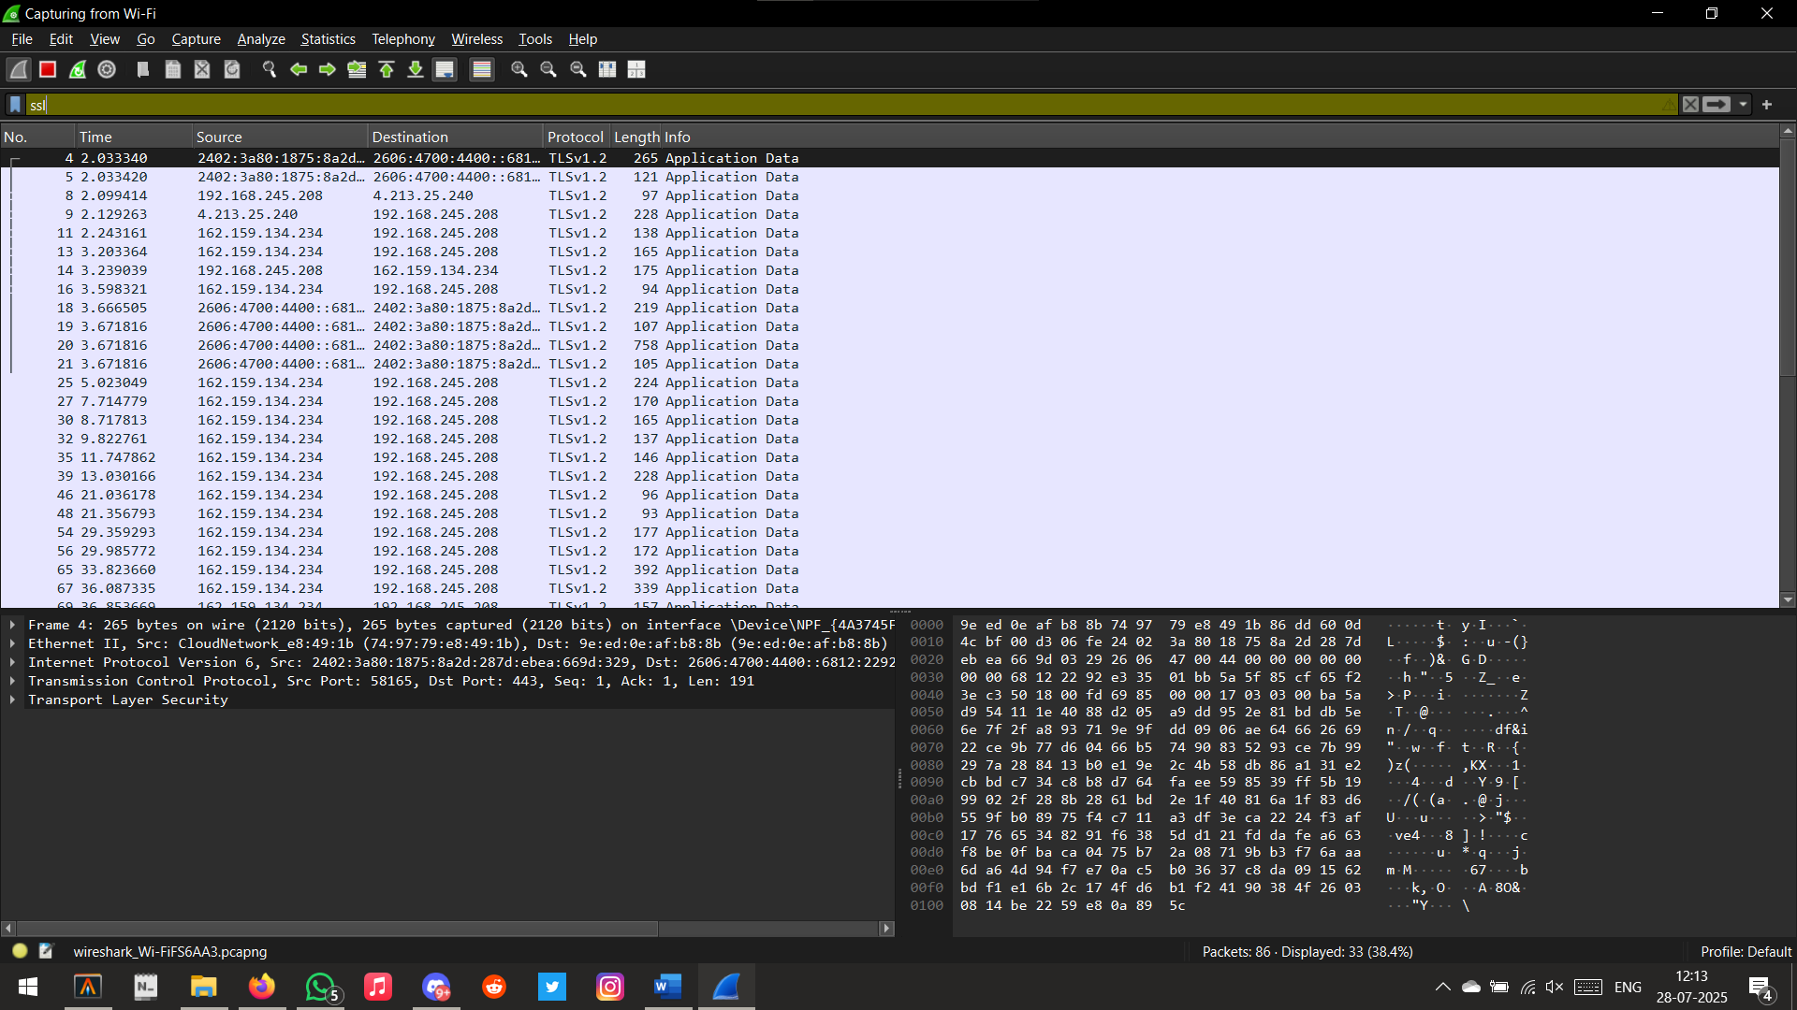

1. Ip and ip.addr == ?

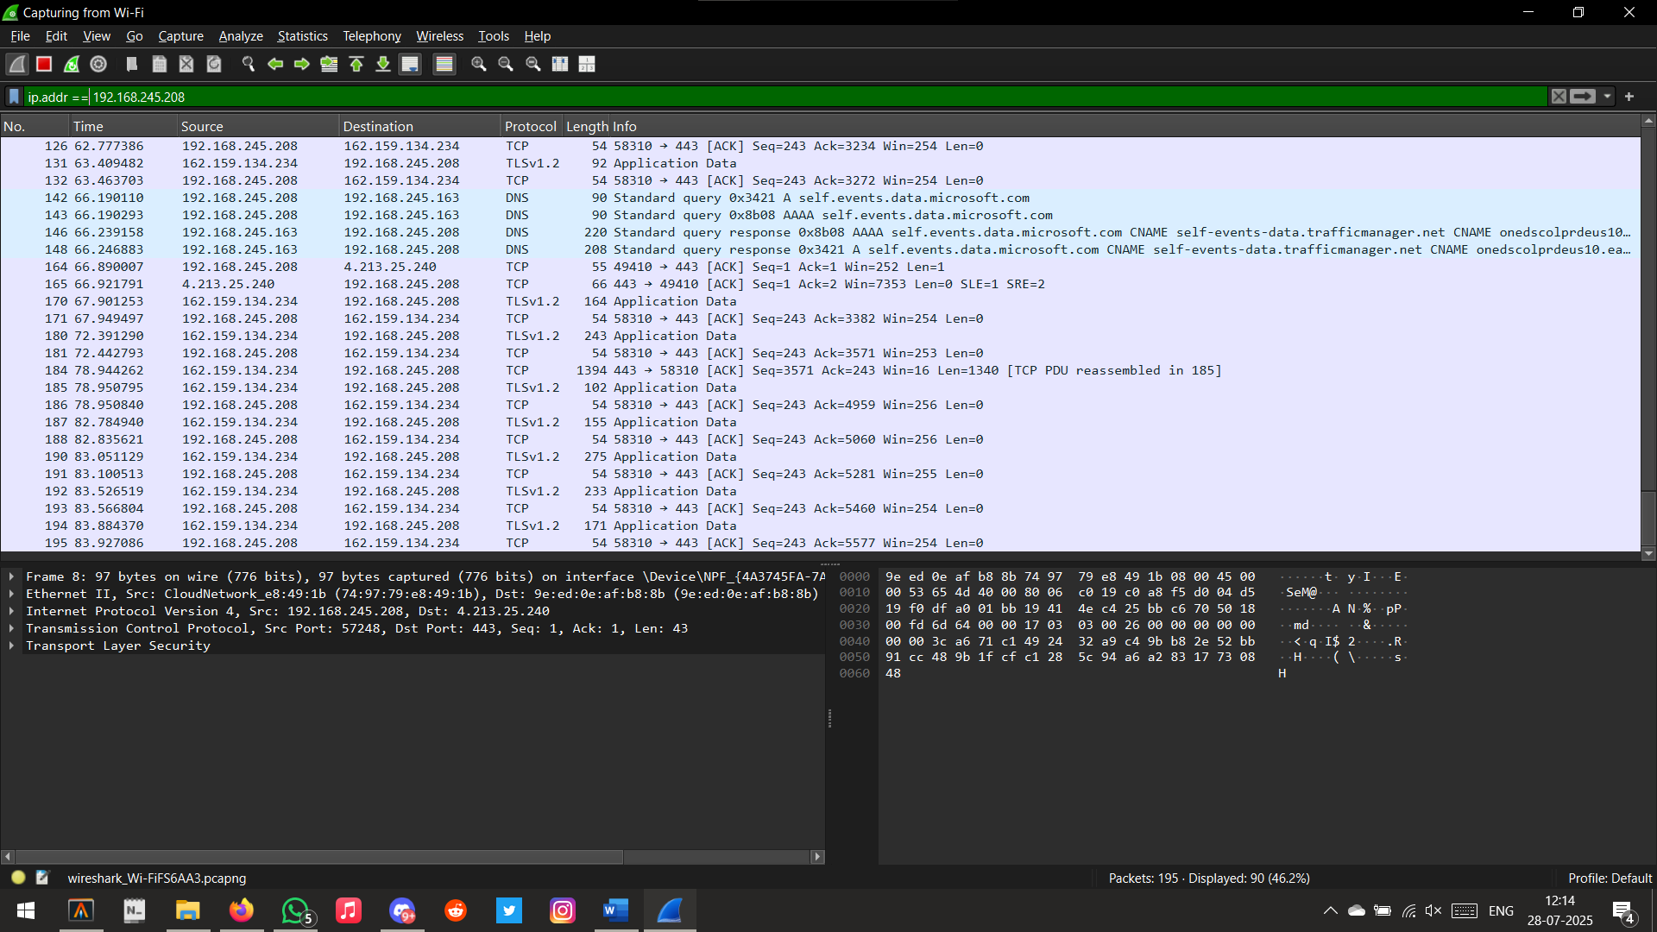

1. http.request

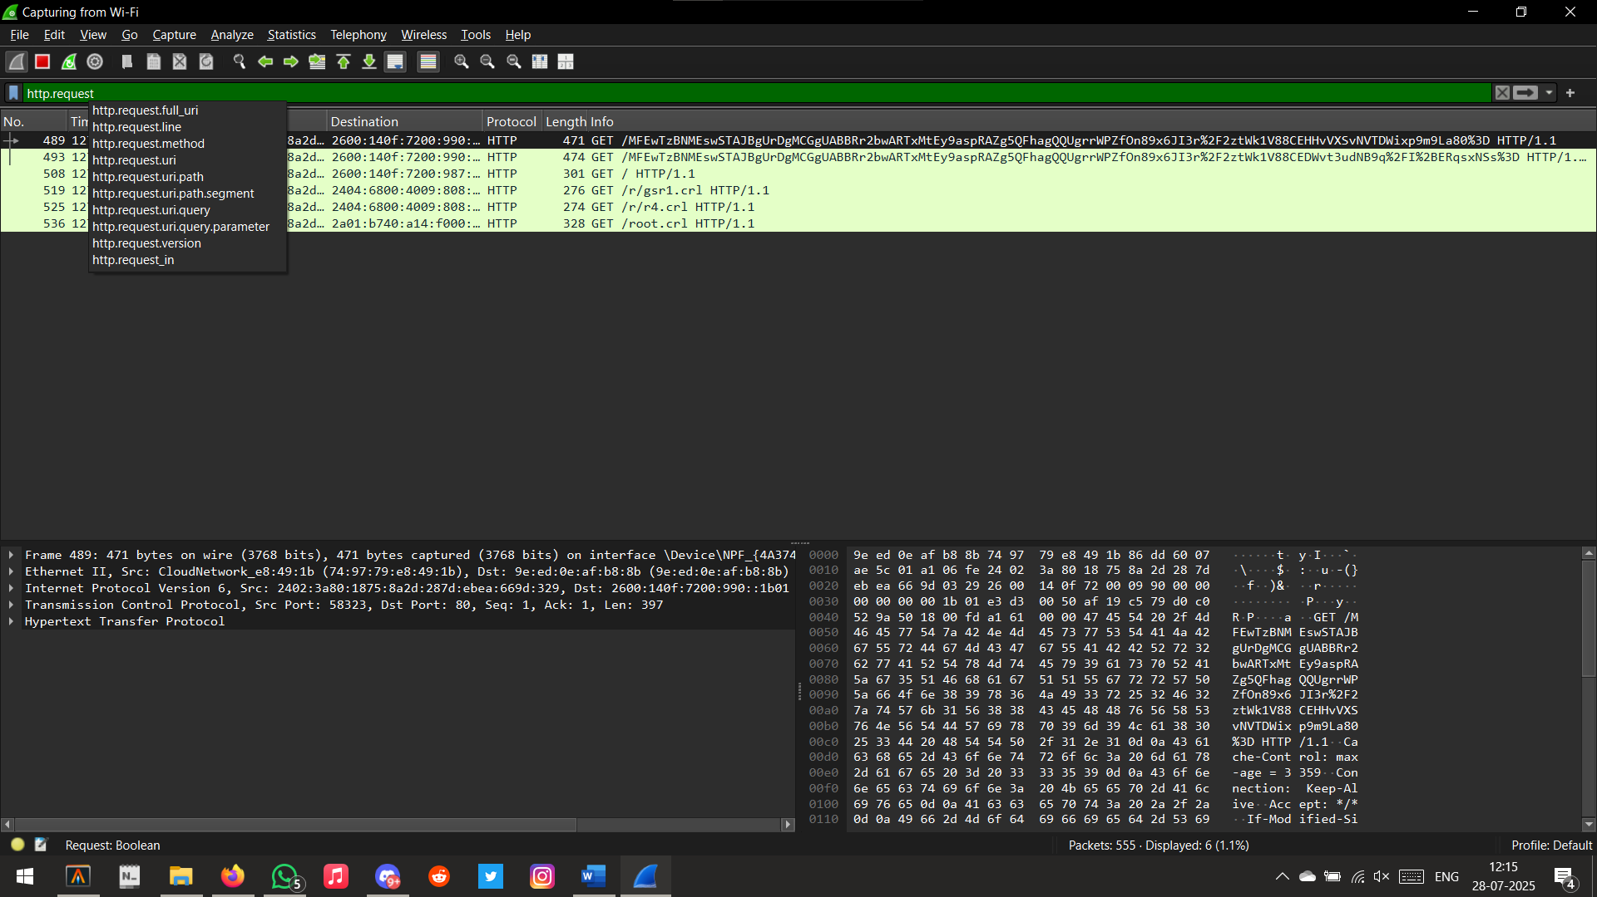

1. tcp.port == 443

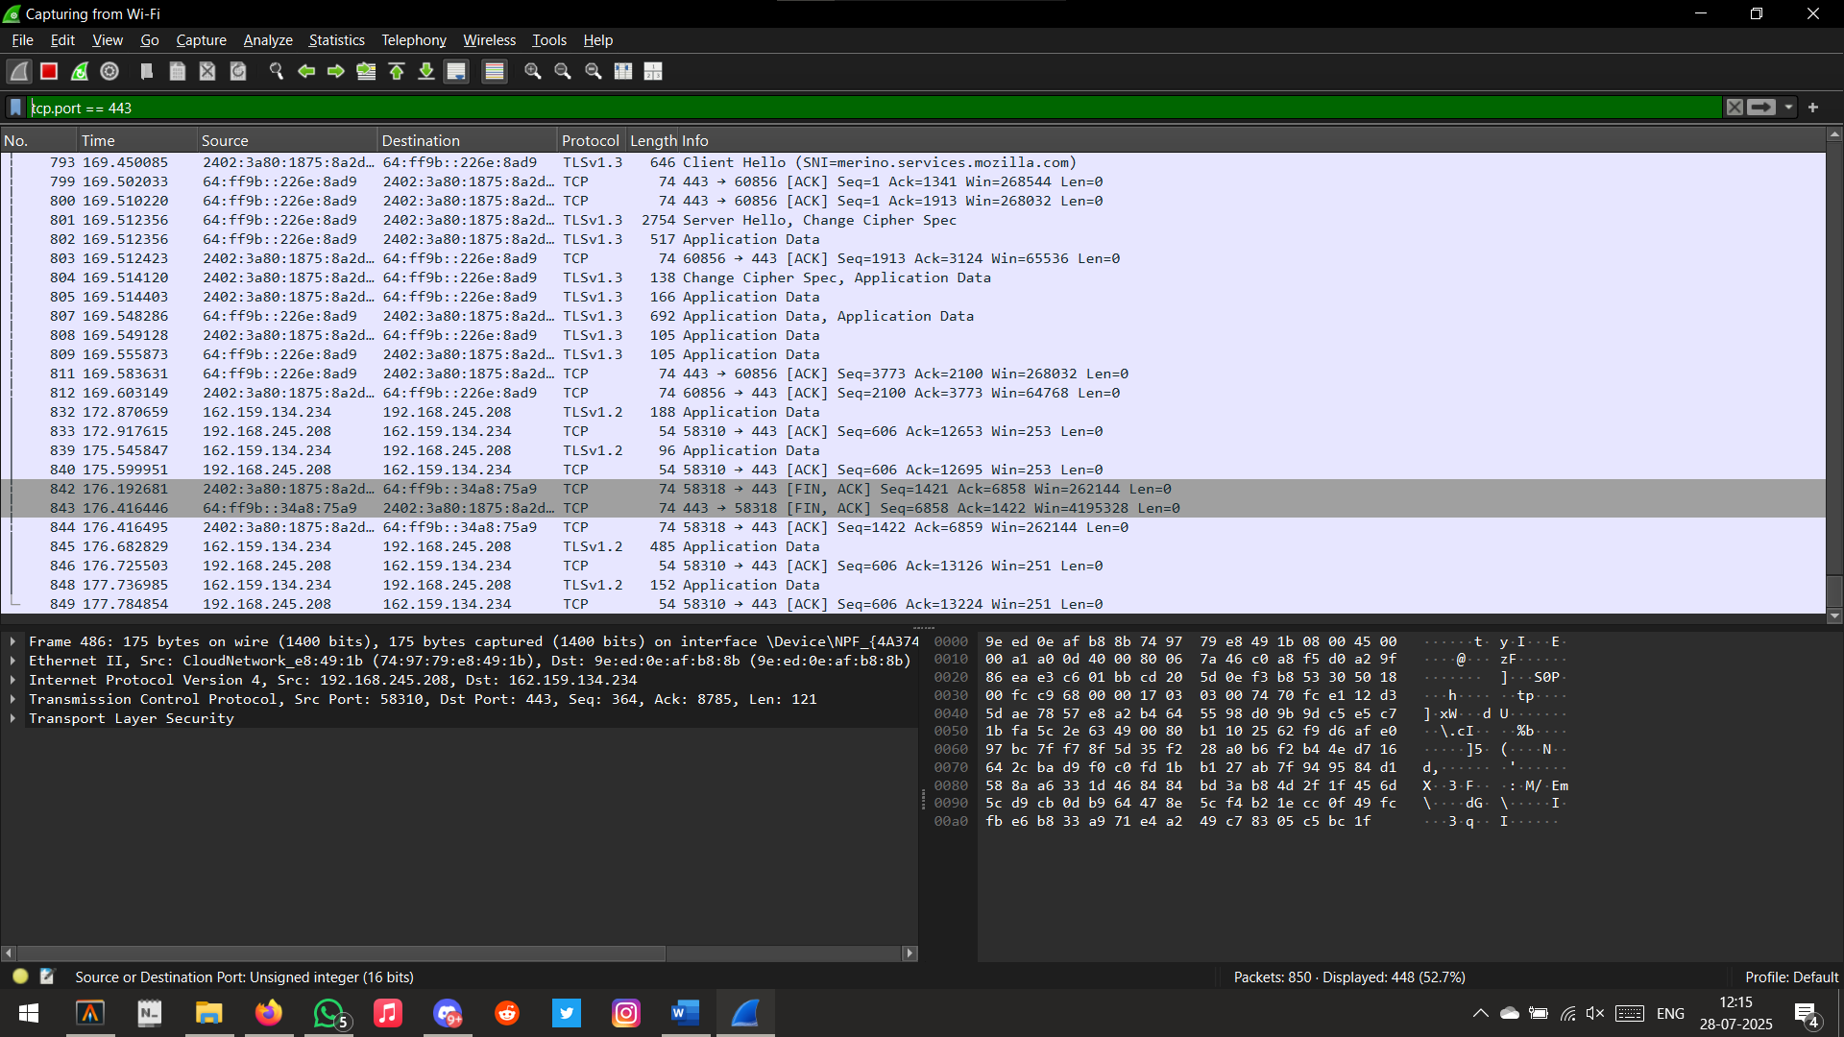

1. arp

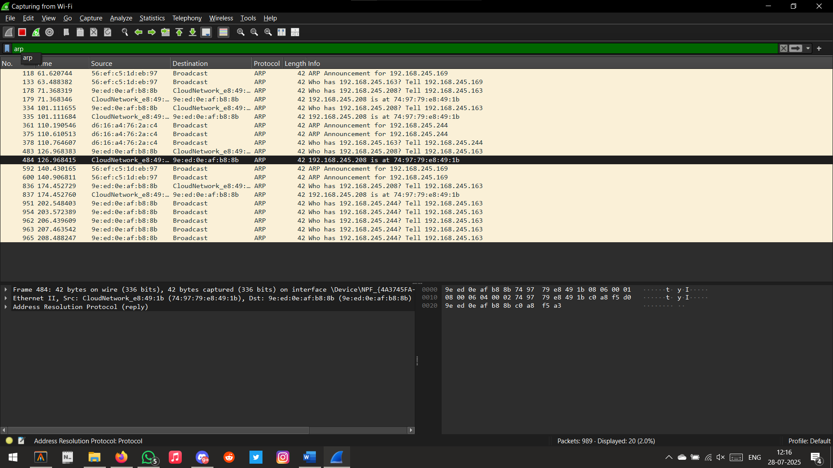

1. dns

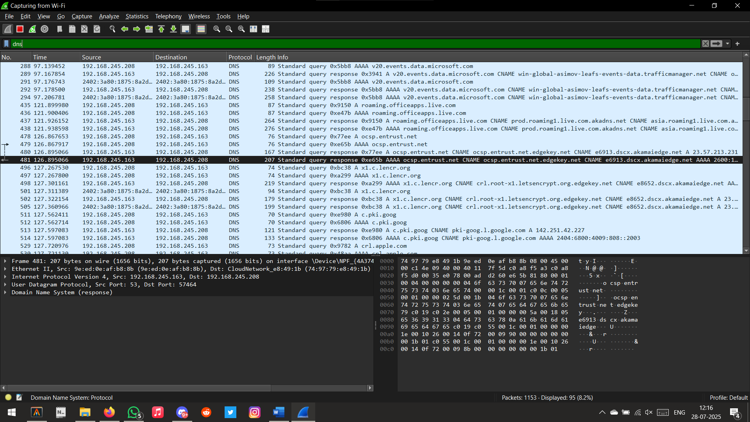

1. while Youtube is playing

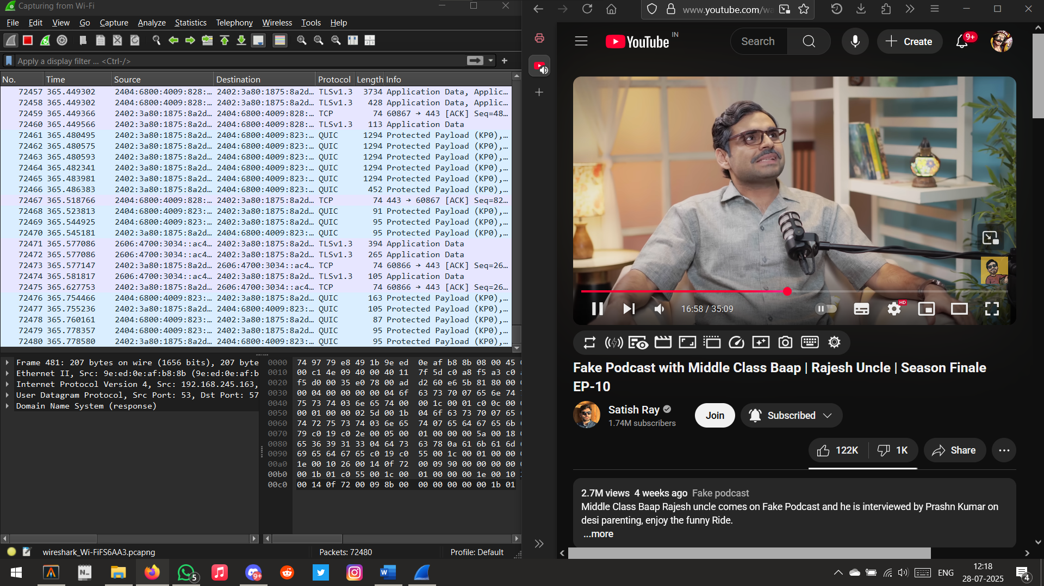

1. udp

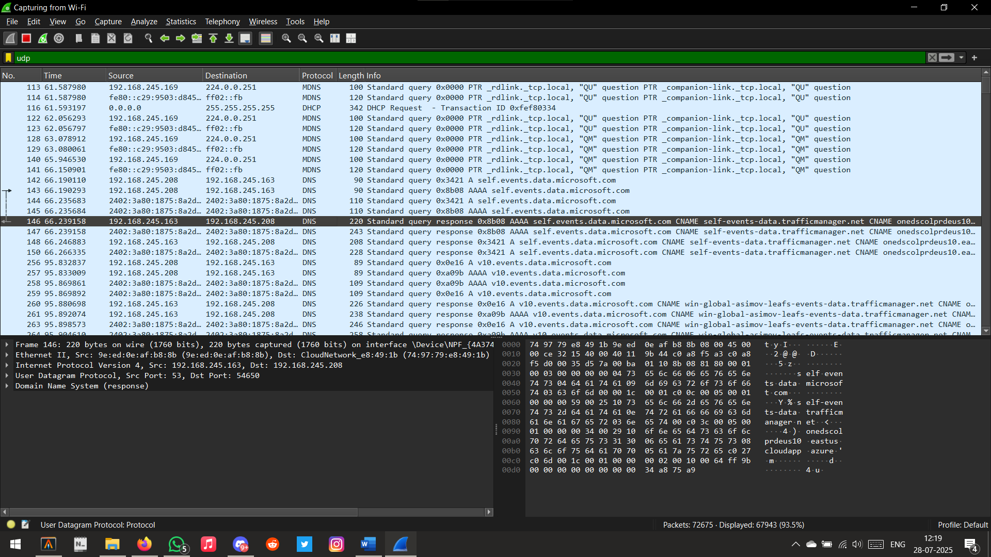

1. tcp

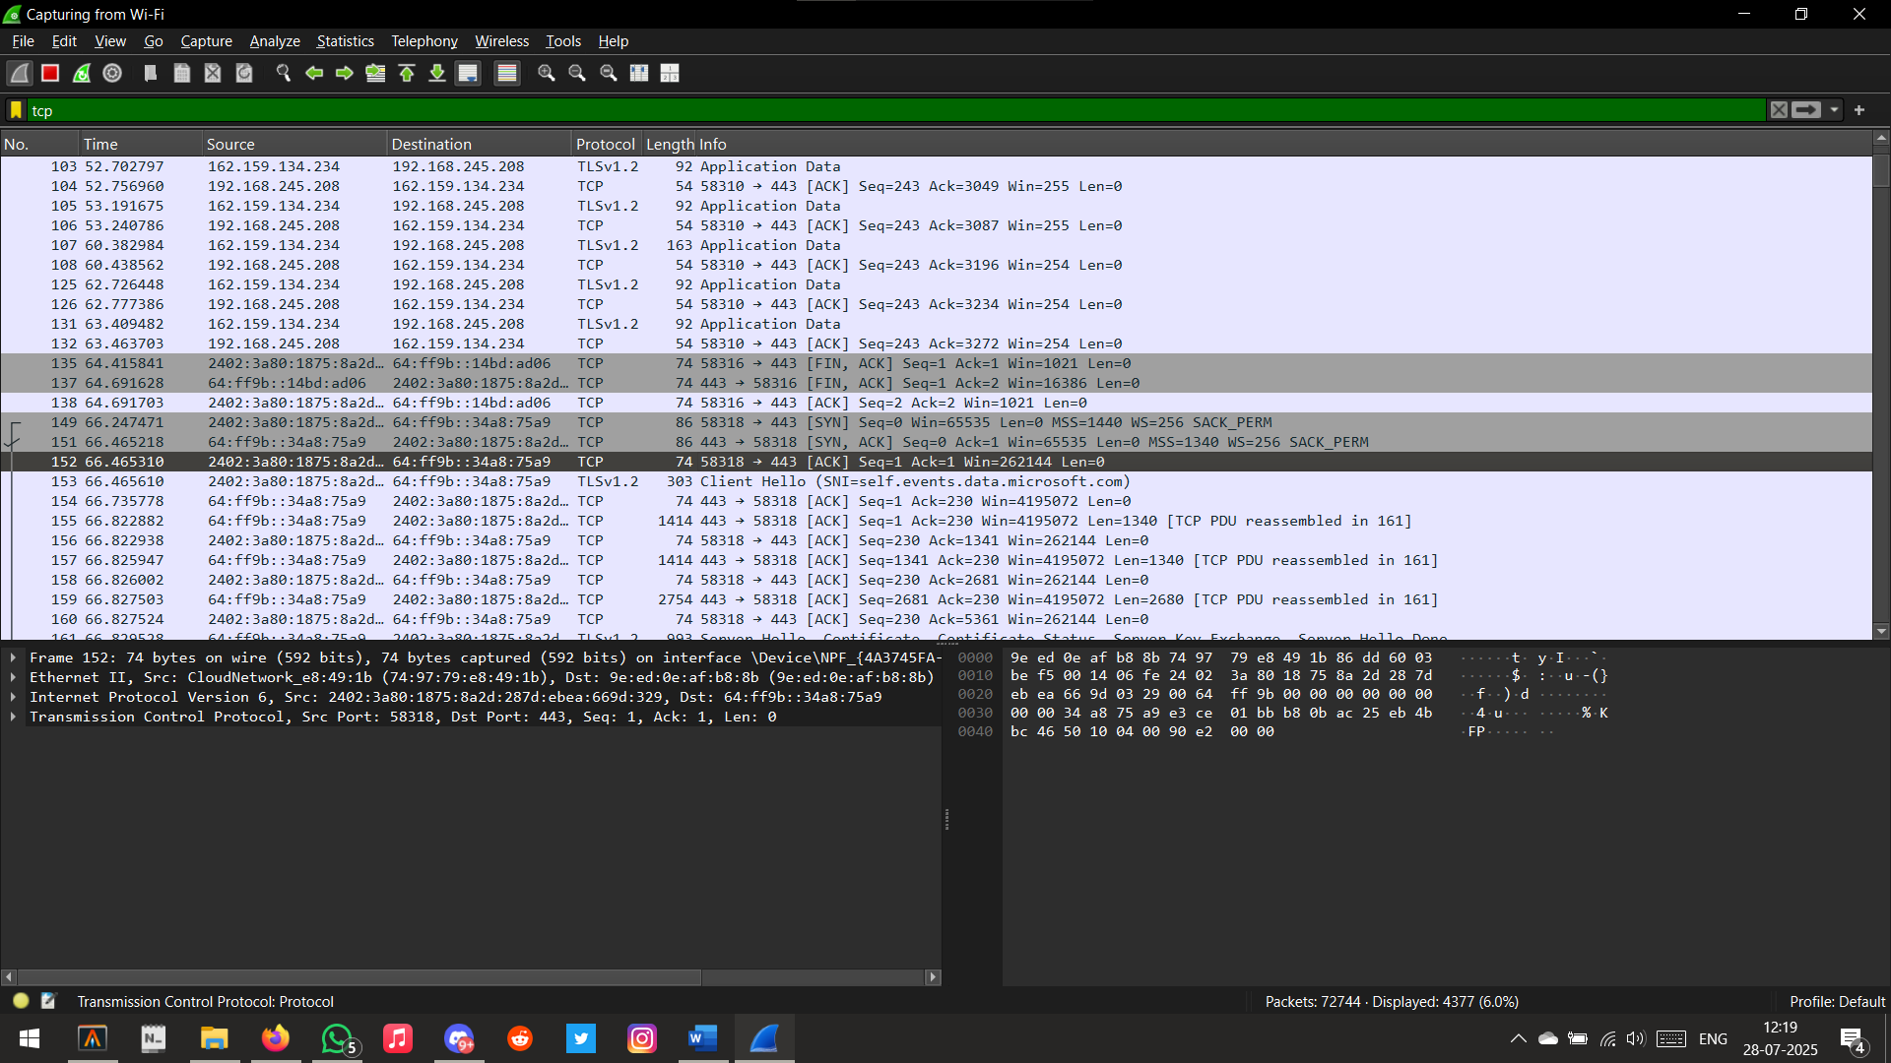

|  |  |  |  |  |  |
| --- | --- | --- | --- | --- | --- |
| Performance  (7M) | Journal  (3M) | Lab Ethics  (2M) | Attendance  (3M) | Total  (15M) | Faculty Signature |
|  |  |  |  |  |  |